Faktlens Digital Services - Azure Migration Project
Session 1 - Architecture & Solution Design
Daniel Igbu (GMNSE), Junior Cloud Engineer, student
This report covers the six tasks required for Session 1 of the Faktlens Digital Services capstone project: extracting the client's technical requirements, designing the target architecture, choosing an Azure region, setting a naming convention, comparing VM and PaaS hosting, and producing a deployment checklist for the sessions ahead.
1. What Faktlens Actually Needs
Faktlens Digital Services is a small business moving part of its IT to Azure. Before getting technical, here's the brief in plain terms:
- A working company website the public can reach
- A properly separated network, not everything sitting in one open space
- Somewhere to store documents and images that isn't just "public on the internet"
- Different people (CEO, IT admin, finance) get different levels of access
- Some way to notice if something's wrong, and to keep an eye on cost
- A backup/recovery plan in case something breaks
2. Technical Requirements
# | What the client asked for | What that means technically | Where it's handled
1 | Host the company website on Azure | Windows Server VM running IIS, reachable over the internet | Sections 3, 4, 8
2 | Create a Resource Group and structured environment | One Resource Group (Faktlens-Cloud-RG) holding every resource | Sections 3, 4
3 | Build a VNet with appropriate subnets | Faktlens-VNet split into WebSubnet and ManagementSubnet | Sections 3, 4
4 | Deploy a Windows Server VM for IIS | Faktlens-Web01, placed in WebSubnet | Sections 3, 4, 8
5 | Configure NSGs and secure administration | Faktlens-Web-NSG: only 80/443 open publicly, RDP locked to one IP | Sections 3, 7
6 | Create Blob Storage for documents and images | faktlensstorageXXXX with separate containers, kept private | Sections 3, 4, 8
7 | Apply Microsoft Entra ID / RBAC concepts | Role-based access for CEO, IT Admin, Finance Officer | Sections 3, 4, 8 (built out fully in Session 6)
8 | Configure Azure Monitor, alerts and cost controls | Azure Monitor with a metrics alert and a budget alert | Sections 3, 4, 8
9 | Understand backup and disaster recovery | RPO/RTO planning for the VM and stored files | Noted in checklist; covered properly in Session 10
10 | Evaluate App Service as a PaaS alternative | Compare VM hosting against a managed PaaS option | Section 6 (full evaluation in Session 11)
11 | Introduce Azure Functions and Infrastructure as Code | Not needed for the website itself, but worth knowing | Left for Sessions 12 and 13
12 | Produce documentation and defend the solution | A written record of every decision, ready to present | This report, and every session report after it

3. Architecture
The diagram below shows how a visitor's request travels from the internet, through the firewall (NSG), into the subnet where the website's VM lives, and how storage, monitoring, and identity sit alongside to support everything. The numbers on the diagram match the numbered key underneath it, so it can be followed step by step even without an Azure background.
The main design decision is splitting the network into two subnets instead of one. WebSubnet only ever deals with normal visitor traffic on ports 80/443. ManagementSubnet is where I'd actually log in to administer the server, locked to just one IP. Keeping those apart means a problem on the public side of the site can't automatically hand someone a path to the admin side.
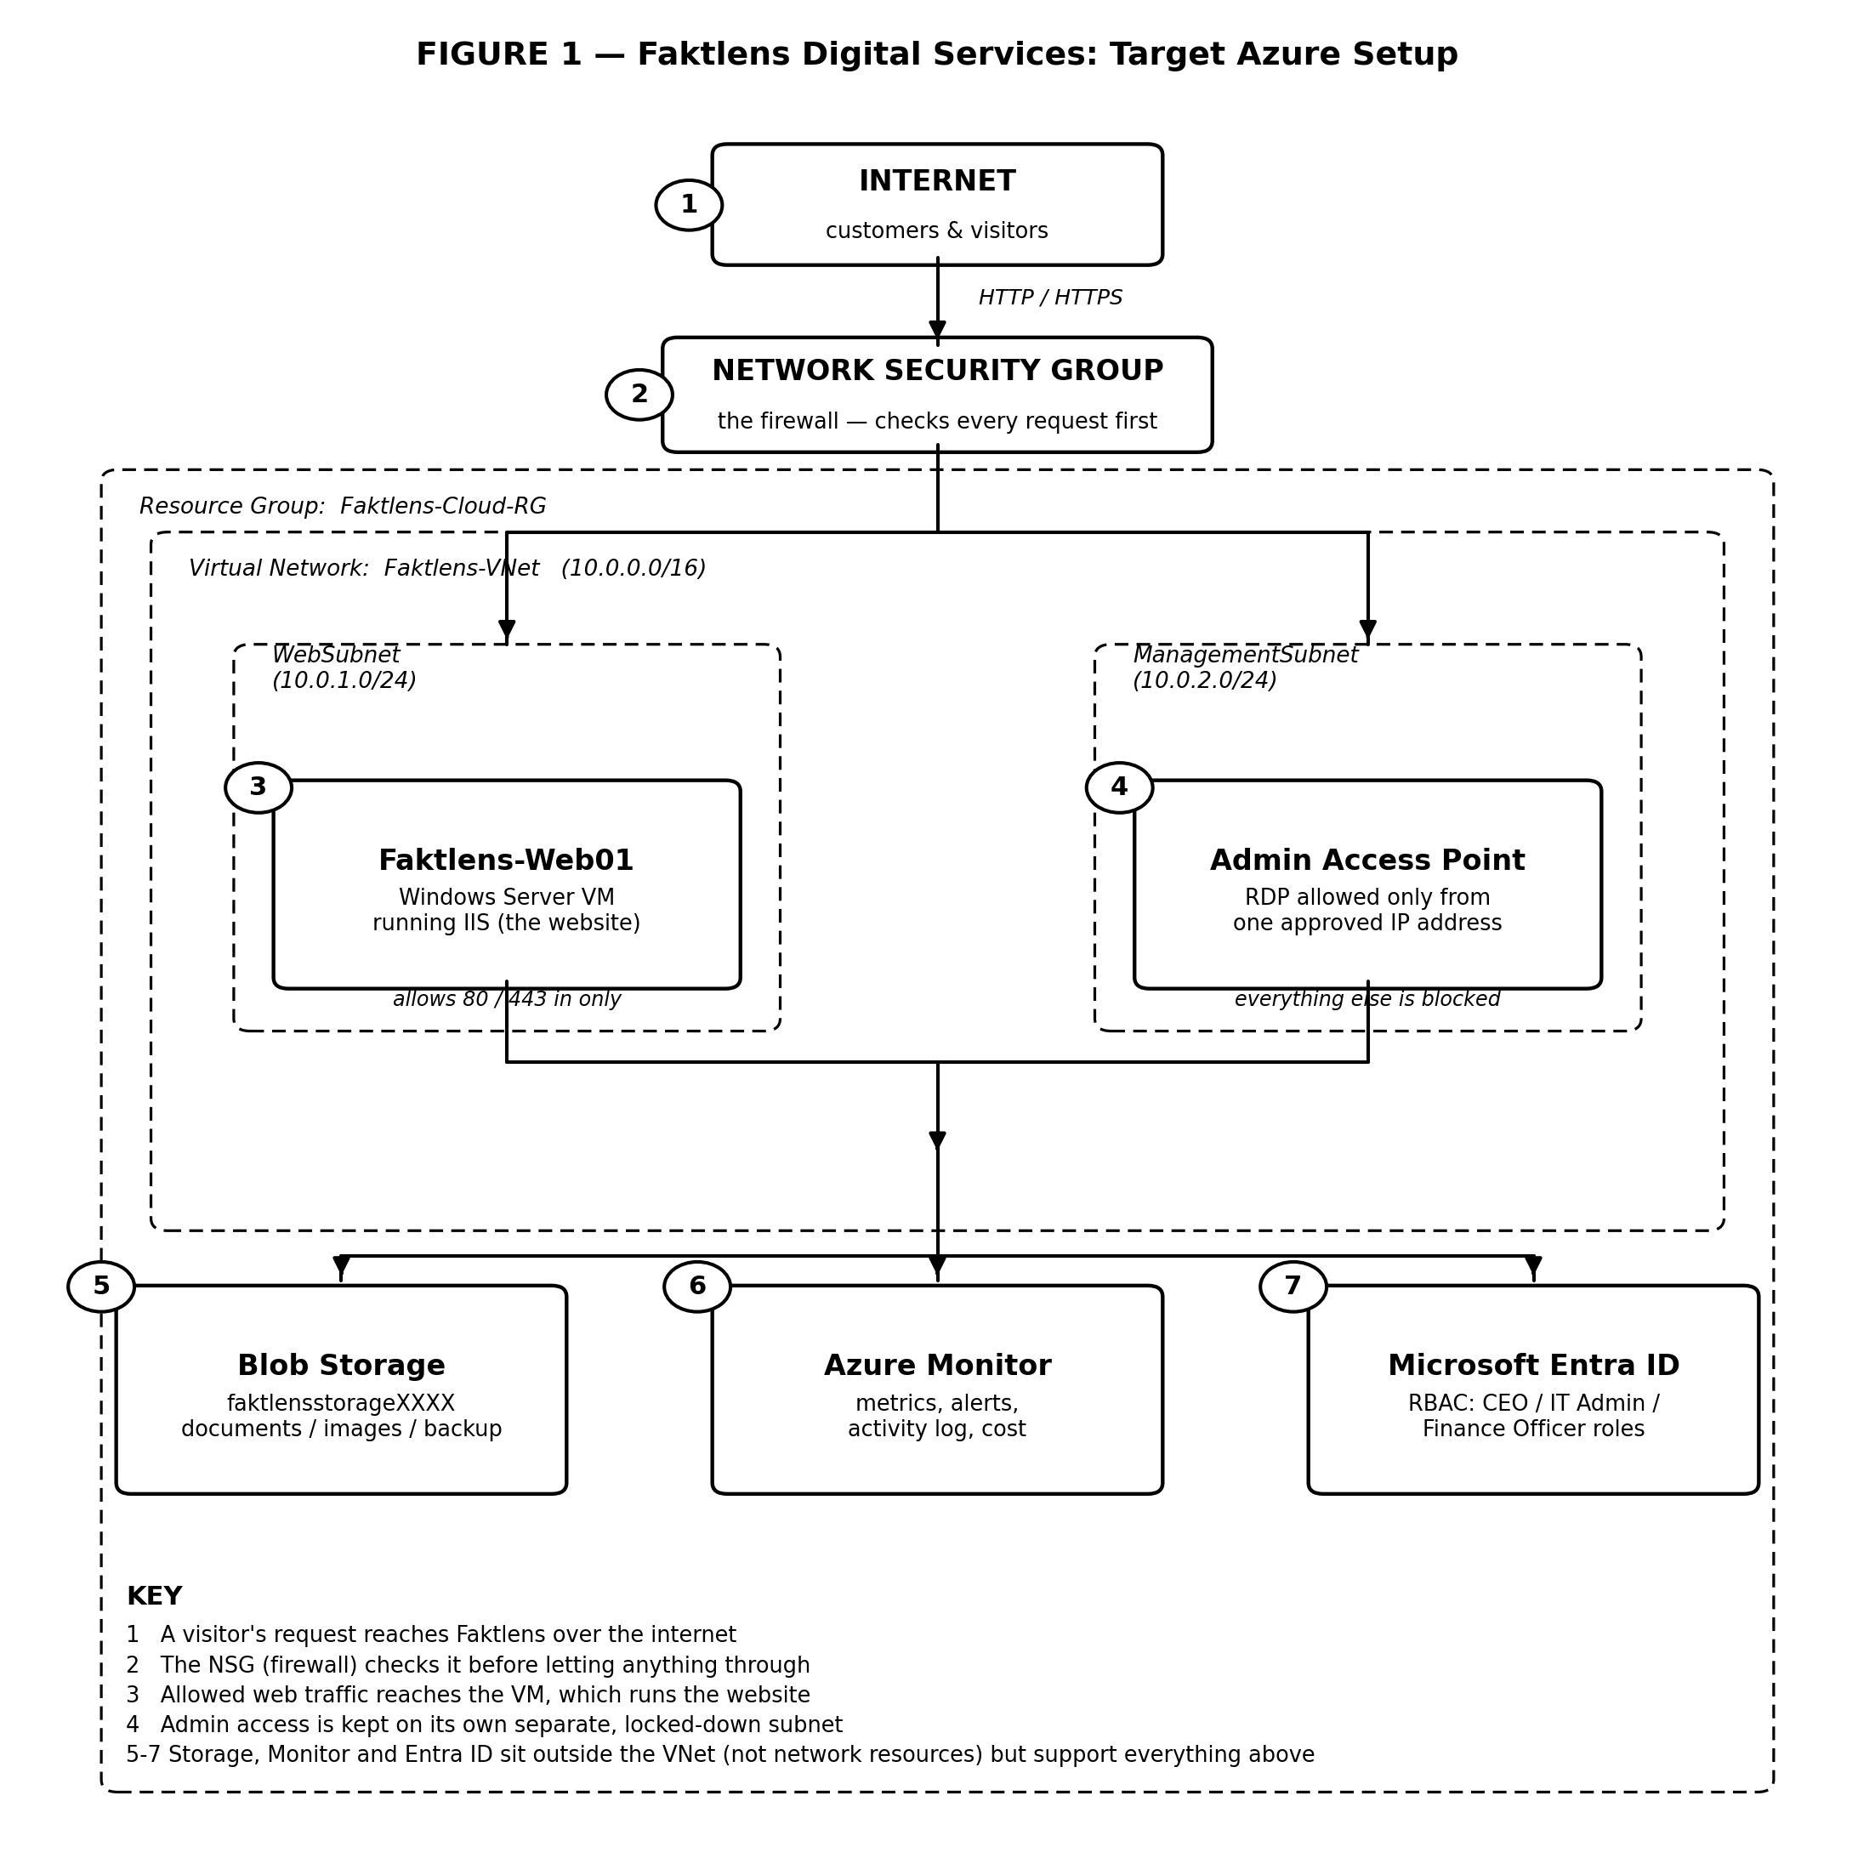
4. Naming Convention
Resource | Name | Why
Resource Group | Faktlens-Cloud-RG | Everything for this client sits under one group, easier to manage, track, and bill
Virtual Network | Faktlens-VNet (10.0.0.0/16) | One private network for all of Faktlens' Azure resources
Web Subnet | WebSubnet (10.0.1.0/24) | Where the public-facing server lives
Management Subnet | ManagementSubnet (10.0.2.0/24) | Kept apart from WebSubnet on purpose. This is where admin access happens
Network Security Group | Faktlens-Web-NSG | The firewall rules deciding what's allowed into WebSubnet
Public IP | Faktlens-Web01-PIP | The address the website is actually reached on
Virtual Machine | Faktlens-Web01 | 01 so a second server (Web02) can be added later without renaming anything
Storage Account | faktlensstorageXXXX | Storage account names have to be globally unique across all of Azure, so I'll add a random suffix when I create it
Monitor / Logs | Faktlens-Logs | Where metrics and alerts get collected
Action Group | Faktlens-metrics | automated notification and response team
Metric Alert Rule | Faktlens-web01-CPU-alert | a smart threshold monitors or gauge reader
Cost/Billing | Faktlens-Monthly-Budget | A act as a smart spending guardrail to stop that from happening
5. Region
Going with South Africa North (Johannesburg). It's the Azure region closest to Nigeria, so it should keep latency lower for local users than routing everything through Europe, and it's currently one of the only Azure regions on the African continent. If it's ever unavailable on the training subscription, West Europe is the fallback: it's one of Azure's largest regions, and nothing on the requirement list needs a specific region to work.
6. VM vs. App Service
Going with a Windows Server Virtual Machine running IIS for this deployment. The client wants full control of the server, and it's also the better learning path for this stage of the internship since I have to manage the OS myself.
Azure App Service is the PaaS alternative. Microsoft handles the OS and patching so there's less to maintain. Worth recommending once the business doesn't need full server-level control.
7. Security Approach
- Only ports 80 (HTTP) and 443 (HTTPS) are open to the internet, and only on WebSubnet
- Admin access (RDP) is restricted to ManagementSubnet and one approved IP
- No passwords, keys, or secrets go into any screenshot or report. That's required by the project's safety rules, and honestly just good practice anyway
8. Deployment Checklist
Rough order I'm planning to follow for the sessions ahead. Some steps depend on earlier ones being finished first (for example, the VM can't go into WebSubnet before WebSubnet exists), so the order matters more than it looks like at first glance.
1 | Confirm the Azure subscription is active and has training credit available
2 | Choose and record the Azure region
3 | Create Resource Group: Faktlens-Cloud-RG
4 | Create Virtual Network: Faktlens-VNet (10.0.0.0/16) with WebSubnet and ManagementSubnet
5 | Create the Network Security Group and attach it to WebSubnet
6 | Add NSG rules: allow HTTP (80) and HTTPS (443) inbound
7 | Add NSG rule: restrict admin access (RDP) to one known IP only
8 | Deploy the Windows Server VM (Faktlens-Web01) into WebSubnet
9 | Install IIS, confirm it's running, then deploy the website files
10 | Test the site both locally (on the VM) and externally (from the public IP)
11 | Create the Storage Account (faktlensstorageXXXX) with containers: documents, images, backup
12 | Set up Microsoft Entra ID / RBAC with least-privilege roles for CEO, IT Admin, Finance Officer
13 | Turn on Azure Monitor, create a metrics alert, and set a budget/cost alert
14 | Write down the backup and disaster recovery approach (RPO/RTO)
15 | Test the whole environment end-to-end and save screenshots as evidence
16 | Stop or delete anything not needed between sessions, to keep cost down

SOLUTION DESIGN
Business Requirement
Faktlens Digital Services wants part of its IT moved to Microsoft Azure: a hosted company website, a secure place to keep documents and images, controlled admin access, and a way to keep an eye on both performance and cost as the setup grows.
Assumptions & Constraints
- Training and test resources only, nothing on this project touches real customer data
- Resource sizes kept small and cost-conscious throughout, checked against current pricing before anything is created
- Chargeable resources get stopped or deleted between sessions rather than left running
- If a feature is unavailable due to subscription or tenant restrictions, that gets documented rather than worked around
Region
South Africa North. It's the closest Azure region to Nigeria, which keeps latency down for local users, and it's one of the only Azure regions on the African continent. West Europe is the fallback if it's ever unavailable on the training subscription.
VM vs. PaaS Decision
Hosting the site on a Windows Server VM running IIS, not App Service. The client needs full control of the OS at this stage, and managing it by hand. App Service stays on the table as the PaaS option once the business no longer needs that level of server control.
Core Components
- Resource Group (Faktlens-Cloud-RG): keeps every project resource in one place
- Virtual Network with two subnets: keeps public web traffic separate from private admin traffic
- Network Security Group: the firewall rules deciding what traffic is let in or out
- Windows Server VM with IIS (Faktlens-Web01): runs the company website
- Blob Storage (faktlensstorageXXXX): holds documents and images for the business
- Microsoft Entra ID / RBAC: controls who can access what, kept as narrow as possible
- Azure Monitor: tracks performance, availability, and cost, with alerts turned on
Security Approach
- Only ports 80 (HTTP) and 443 (HTTPS) are open to the internet, and only on WebSubnet
- Admin access (RDP) is restricted to ManagementSubnet and a single approved IP
- No passwords, keys, or secrets appear in any screenshot or report, as required by the project's safety rules

Summary
The website runs on Faktlens-Web01 inside WebSubnet, sitting behind an NSG that only allows web traffic in. Administration happens through a separate, locked-down ManagementSubnet, so visitors and whoever's managing the server never share the same door. Documents and images live in Blob Storage, kept private by default. Access to the environment itself is controlled through Entra ID and RBAC, so the CEO, IT admin, and finance officer each get only what their role needs. Azure Monitor and Cost Management watch performance and spend in the background. As the business grows, App Service and Azure Functions are the natural next step, and that comparison gets a proper look in a later session, once this VM-based setup is proven to work.

